IC ENGINE
ENGINE: It’s device which converts one form of energy into other useful mechanical form.
EXTERNAL COMBUSTION ENGINE | INTERNAL COMBUSTION ENGINE
Combustion take place outside the mechanical engine. | Combustion take place inside the mechanical engine.
E.g. Steam Engine Closed Gas Turbine Engine | RECIPROCATING ICE | ROTARY ICE
 | E.g. Modern ICE | E.g. Wankel Engine
NOTE: In external combustion engine, the combustion product transfer heat to the working fluid, where as in internal combustion engine the product of combustion produce power directly in the same cylinder.
RECIPROCATING IC ENGINE:
Air + Chemical Energy of Fluid | Combustion | Heat | Expansion | Mechanical Work
HISTORY OF DEVELOPMENT OF IC ENGINE:
- 17th Century (1680) – Christian Huygens has developed engine. Fuel used is Gun powder. Upward stroke is because of explosion of Gun powder. Return stroke is because of vacuum created due to cooling of hot combustion products (Power Stroke). It’s Atmospheric Engine.
NOTE: In next 180 years there is not much development in IC engine because of lack of good quality fuel. In 1858, the discovery of crude oil and in 1888 development of pneumatic rubber tire made automobile practical.
- The first practical engine was invented by Jean Joseph Étienne (JJE) Lenoir in 1860. It’s an atmospheric engine which has maximum efficiency 5%. It’s based on Lenoir Cycle.
WORKING: Half of first stroke is suction, then suction valve is closed and A:F mixture ignited without any compression and heat is added at constant volume then the piston expand in 2nd half of the first stroke and power is developed. At the end of first stroke exhaust valve is open and exhaust process take place.
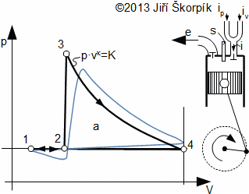 |  | 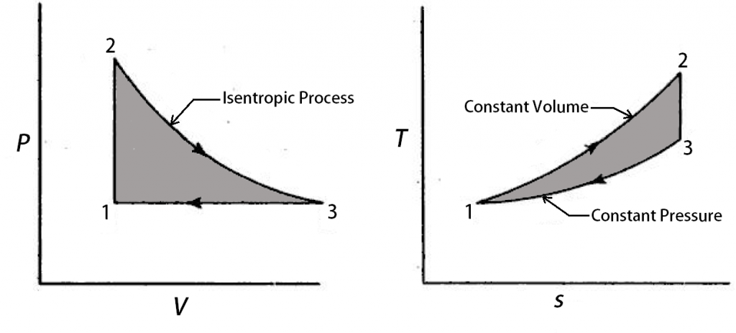
$$q_{in}=C_{V}(T_{2}-T_{1})$$ | $$q_{out}=C_{P}(T_{3}-T_{1})$$ |  | $$η={q_{out}}/{q_{in}}=1-\left[{\left(T_{3}-T_{1}\right)}/{\left(T_{2}-T_{1}\right)}\right]$$
$$r_{p}={P_{2}}/{P_{1}}={P_{2}}/{P_{3}}$$ | For 1-2: $T_{2}=T_{1}r_{p}$ |  | For 2-3: ${T_{3}}/{T_{2}}={\left(r_{p}\right)}^{{-\left(γ-1\right)}/γ}⇒{T_{3}}/{T_{1}}={\left(r_{p}\right)}^{1/γ}$
From Above Equations, $η=1-\left[{\left({\left(r_{p}\right)}^{1/γ}-1\right)}/{\left(r_{p}-1\right)}\right]$
- Father of IC engine (Nikolaus Otto) has developed four stroke SI engine in 1876. Nikolaus Otto considered as further of modern IC engine. In Otto engine Air fuel mixture was compressed before being ignited. Nikolaus Otto patented the 4-stroke engine when he was only 34.
- In 1881 Daugald Clerk developed first 2-Stroke engine. He utilized a separate cylinder for compressing the charge.
- In 1885 Atkinson develops an engine in which expansion is up to atmospheric pressure. In Atkinson cycle have longer expansion than compression.
- In 1892 Rudolf Diesel Developed compression ignition engine.
- In 1885 Karl Benz Developed first automobile powered by IC engine. (Not successful)
- In 1896 Henry Ford developed an automobile powered by IC engine.
- In 1923 Antiknock additive, Tetra ethyl lead discovered by general motors which provide boost to developed of high compression ratio in SI engine.
- In 1956 Felix Wankel developed Rotary IC engine using eccentric rotary design. (Power/ Weigh & RPM is high) Design is very Difficult.
BASIC PARTS OF RECIPROCATING IC ENGINE:
- STRUCTURAL COMPONENTS:
CYLINDER HEAD AND CYLINDER BLOCK: Cylinder block is the part of Engine frame that contains cylinder in which piston moves. It supports liners and head. Cylinder head serves to admit, confine and release fuel/ Air. It cover to cylinder block and supports valve train.
CRACK CASE: Engine Frame Section that houses the crank shaft.
OIL SUMP: Reservoir For collecting and holding lube oil.
- MOVING COMPONENTS:
PISTON: Light weight and strong. Commonly made of aluminium alloys.
PISTON RINGS & OIL RINGS: Transfer heat form piston to cylinder. Seal Cylinder & distribute lube oil. Both are made of silicon.
CRANK SHAFT & CONNECTING ROD: Converts reciprocating motion to rotary motion. Crack shaft derives cam shafts, Generator, pump etc.
DUDGEON PIN: Connects Piston and connecting rod.
CRANK PIN: Connects connecting rod to crank.
FLYWHEEL: Absorbs and release kinetic energy of piston strokes and smoothens rotation of crankshaft.
VALVES:
- Intake: Open to admit air to cylinder (With fuel in Otto Cycle).
- Exhaust: Open to allow gases to be rejected.
Camshaft, Cams and rocker arms/ Puss rod system is used for valve operation.
ENGINE NOMENCLATURE:
DEAD CENTRE: Location where the piston reverses it’s direction.
For Vertical Position. | TDC: Location where the piston is nearest to the cylinder head. | BDC: Location where the piston is farthest to the cylinder head. | $$1 Revolution =2 Stroke of Piston$$
For Horizontal Position. | $$TDC=IDC$$  Inner Dead Centre | $$BDC=ODC$$  Outer Dead Centre | $$Stroke=TDC-BDC$$
CLEARANCE VOLUME ($V_{C}$): when the piston is at TDC then the volume of cylinder is minimum and this minimum volume s known as clearance volume.
SWEPT VOLUME ($V_{S}$): Volume displaced by the piston when it moves from TDC to BDC.
$$V_{S}=\left(π/4\right)D^{2}L, Where L=2*crack Radius$$
BORE ($D$): Inner diameter if the cylinder.
CLASSIFICATION OF IC ENGINE
2 STROKES |  | 4 STROKES
More Power Generation for Same Size. |  | Less Power Generation for Same Size.
SI: Petrol Engine. E.g. Scooters | CI: Diesel Engine E.g. Old Trucks, Generator | SI: Petrol Engine. E.g.  Cars & Bikes | CI: Diesel Engine E.g. Buses, Diesel Generator
4 STROKES (SI):
- Suction Stroke: Piston Moves from TDC to BDC. Crankshaft rotates through $180°$. Inlet Valve opens and charge is sucked into the cylinder due to pressure difference.
- Compression Stroke: Inlet Valve and Exhaust valve are closed. Piston Moves from BDC to TDC. Pressure & Temperature of charge increases. Crankshaft rotates through $360°$. E.g. 1 Revolution is completed.
- Expansion/ Power Stroke: Charge is ignited by spark before the piston reaches TDC. Sudden increase in the temperature and pressure but the volume remains constant. Combustion products pushes the piston in the downward direction due to high pressure. Heat energy transform to mechanical energy and piston moves from TDC to BDC. Crank shaft rotates through $540°$. Both inlet & Exhaust valves are closed.
- Exhaust Stroke: Exhaust valve opens as the piston moves from BDC to TDC. Piston pushes the product of combustion through exhaust valve into atmosphere.
Theoretical Valve Timing Diagram | Actual Valve Timing Diagram
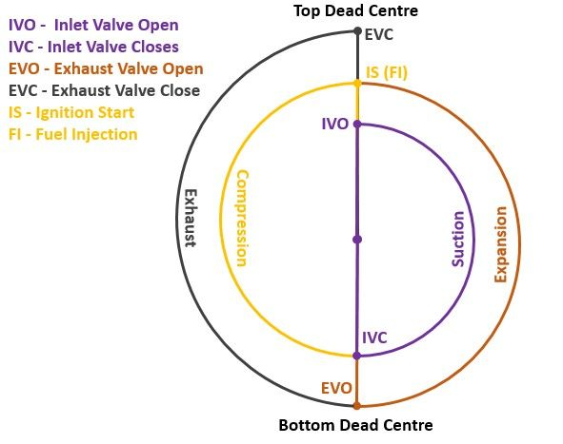 | 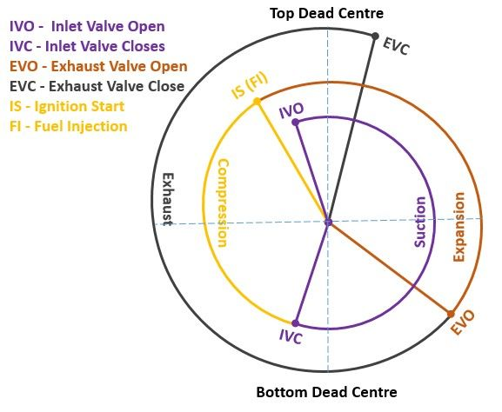

ACTUAL VALVE TIMING DIAGRAM:
- Inlet Valve is open $5°$ to $10°$before TDC. This is to ensure that the valve will be fully open and fresh charge start entering to the cylinder ASAP.
- Inlet valve closed $10°-60°$ after BDC to take the advantage of momentum of rapid moving gases (Ram effect).
- Ignition occurs $15°-30°$ before TDC this is to allow the time delay between spark and completion of combustion.
- Pressure at the end of power stroke is above the atmospheric pressure which increases the work to expel the gases.
- Exhaust valve open $25°-55°$ before BDC the pressure reduced to atmospheric pressure and useful work is saved.
- The exhaust valve closed $5°-20°$ after TDC so that inertia of gases tends to scavenge the cylinder which will increases the volumetric efficiency.
For low Speed engine all angles are less and for high speed engines all angles are high.
4 STROKES (CI):
- It’s like 4 stroke SI engine except that a high compression ratio is used during the suction stroke air alone instead of air fuel mixture is inducted.
- Due to high compression ratio the temperature at the end of compression stroke is enough to ignite the fuel.
- High pressure fuel pump and injector is used to inject the fuel.
- No carburettor and no ignition system required.
- Engine have High efficiency and heavier than SI engine, because of high compression ratio.
4 STROKE SI | 4 STROKE CI
- IVO: $5°-10°$ Before TDC  - IVC: $10°-60°$ After BDC  - SI: $15°-30°$ Before TDC  - EVO: $25°-55°$Before BDC  - EVC: $5°-20°$ After TDC | - IVO: $10°-30°$ Before TDC  - IVC: $25°-40°$ After BDC  - FVO: $5°-20°$ Before TDC  - FVC: $15°-30°$ After TDC  - EVO: $30°-50°$Before BDC  - EVC: $10°-30°$ After TDC
2 STROKES:
In effective length $L_{eff}$ only power is obtained. During scavenging effect, it may possible in SI engine removes the fresh petrol vapour to the atmosphere Which is loss is the fuel and dangerous to the health. Hence, now a days 2 stroke SI engine is banned.  In 2 stroke engine suction is accomplished by charge compressed in crankcase. The induction of compressed air removes the product of combustion through exhaust port. The air or charge is sucked through spring loaded inlet valve when the pressure in the crack case reduces due to upward motion of piston during compression stroke. After compression stroke the air in crankcase is compressed. Near the end of expansion stroke piston uncovers the exhaust ports, and the cylinder pressure drops to atmospheric as combustion products leave the cylinder. Further motion of the piston covers transfer ports permitting the slightly compressed air or mixture in the crack case to enter the engine cylinder. The top of piston has a projection to deflect the fresh air to sweep up to the top of the cylinder before flowing to the exhaust. During the upward motion of the piston from bottom dead centre, the transfer ports and then exhaust port closed and compression of the charge begins and cycle is repeated. |  |  | 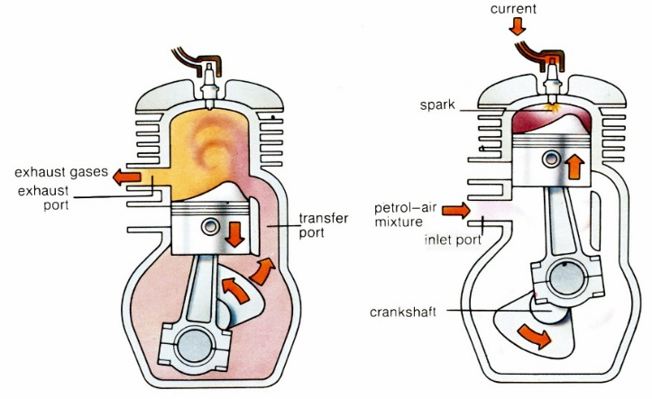  
For SI engine,  EPO: $40°-50°$ Before BDC  TPO: $30°-40°$ Before BDC  EPC: $40°-50°$ After BDC  TPO: $30°-40°$ After BDC  SI: $15°-30°$ Before TDC | For CI engine,  EPO: $40°-50°$ Before BDC  TPO: $30°-40°$ Before BDC  EPC: $40°-50°$ After BDC  TPO: $30°-40°$ After BDC  CI: $15°-30°$ Before TDC  IPO: $5°-10°$ Before TDC  IPC: $10°-20°$ After TDC | 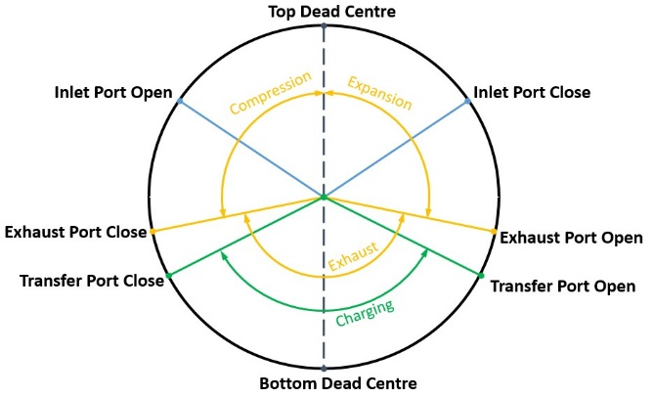

AIR STANDARD OTTO CYCLE:
ASSUMPTIONS:  - Suction and exhaust take place at constant atmospheric pressure.  - Compression and Expansion processes are reversible adiabatic process.  - Combustion process is constant volume heat addition process.  - Exhaust process is constant volume heat rejection process. |  |  | 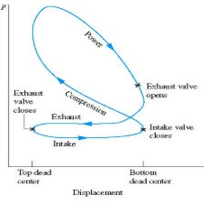
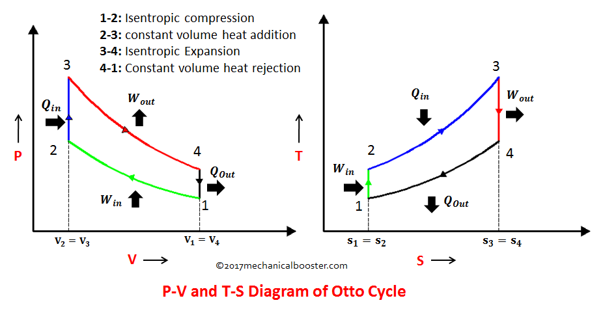
$$q_{in}=C_{V}\left(T_{3}-T_{2}\right)$$ | $$q_{out}=C_{V}\left(T_{4}-T_{1}\right)$$ | $$η=1-\left({q_{out}}/{q_{in}}\right)=1-\left(1/{r^{γ-1}}\right)$$
For 1-2:  $${T_{2}}/{T_{1}}=r^{γ-1}$$ | For 3-4,  $${T_{3}}/{T_{4}}=r^{γ-1}$$ | For increasing η, 1) γ increases which is not practical, 2) $r$ can be increase. $9≤r≤12$
$$W_{net}=q_{in}-q_{out}=C_{V}\left[T_{3}\left(1-r^{-\left(γ-1\right)}\right)-T_{1}\left(r^{γ-1}-1\right)\right]$$
Hence, for maximum $W_{net}$, ${dW_{net}}/{dr}=0⇒r_{opt}={\left[{T_{3}}/{T_{1}}\right]}^{1/{\left[2\left(γ-1\right)\right]}}⇒T_{2}=T_{4}=\sqrt{T_{1}T_{3}}$
Maximum $W_{net}={\left[\sqrt{T_{3}}-\sqrt{T_{1}}\right]}^{2}$
AIR STANDARD DIESEL CYCLE:
ASSUMPTIONS:  - Suction and exhaust take place at constant atmospheric pressure.  - Compression and Expansion processes are reversible adiabatic process.  - Combustion process is constant Pressure heat addition process.  - Exhaust process is constant volume heat rejection process.  Combustion process takes time in comparison with Otto cycle. E.g. Atomisation, Vaporisation, Flame Propagation. |  |  |  | 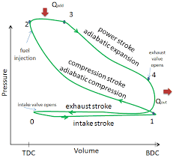
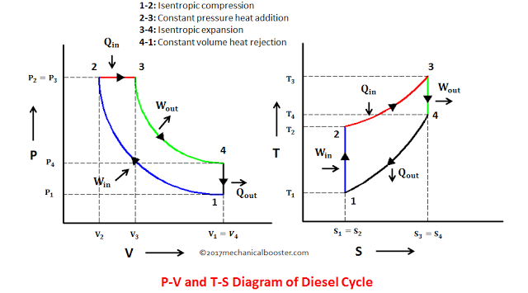
$$q_{in}=C_{P}\left(T_{3}-T_{2}\right)$$ | $$q_{out}=C_{V}\left(T_{4}-T_{1}\right)$$ |  | $$η=1-\left({q_{out}}/{q_{in}}\right)=1-\left(1/γ\right)\left[{\left(T_{4}-T_{1}\right)}/{\left(T_{3}-T_{2}\right)}\right]$$
Compression ratio,  $$r=\frac{V_{1}}{V_{2}}$$ |  | Cut-off ratio,  $$r_{c}=\frac{V_{3}}{V_{2}}$$ |  |  | Expansion ratio,  $$r_{e}=\frac{V_{4}}{V_{3}}=\frac{r}{r_{c}}$$
For 1-2:  $$\frac{T_{2}}{T_{1}}={\left(\frac{V_{1}}{V_{2}}\right)}^{γ-1}=r^{γ-1}$$ |  | For 3-4,  $$\frac{T_{3}}{T_{2}}=\frac{V_{3}}{V_{2}}=r_{c}$$ |  |  | For 3-4,  $$\frac{T_{3}}{T_{4}}={\left(\frac{V_{4}}{V_{3}}\right)}^{γ-1}={\left(r_{e}\right)}^{γ-1}$$
$$η=1-\frac{1}{γ}\left[\frac{T_{4}-T_{1}}{T_{3}-T_{2}}\right]=1-\frac{1}{γ r^{γ-1}}\left[\frac{r_{c}^{γ}-1}{r_{c}-1}\right]$$
For increasing η, 1) γ increases which is not practical, 2) $r$ can be increase. $16≤r≤24$ for size consideration, 3) $r_{c}$ decreasing because by increasing $r_{c},$ $q_{in}$ & $q_{out}$ increse in such a way that $q_{out}>q_{in}$
AIR STANDARD DUAL CYCLE:
For faster engine CI, Dual cycle is followed. For slow engine CI, Diesel cycle is followed.  $$q_{in}=C_{V}\left(T_{3}-T_{2}\right)+C_{P}\left(T_{4}-T_{3}\right)$$  $$q_{out}=C_{V}\left(T_{5}-T_{1}\right)$$ |  |  | 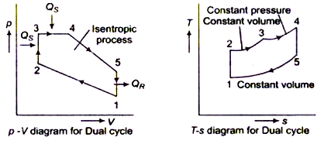
$$r=\frac{V_{1}}{V_{2}}$$ | $$r_{p}=\frac{P_{3}}{P_{2}}$$
$$r_{c}=\frac{V_{4}}{V_{3}}$$ | $$r_{e}=\frac{V_{5}}{V_{4}}=\frac{V_{1}}{V_{4}}=\frac{r}{r_{c}}$$
For 1-2:  $$\frac{T_{2}}{T_{1}}={\left(\frac{V_{1}}{V_{2}}\right)}^{γ-1}=r^{γ-1}$$ | For 2-3,  $$\frac{T_{3}}{T_{2}}=\frac{P_{3}}{P_{2}}=r_{p}$$
For 3-4,  $$\frac{T_{4}}{T_{3}}=\frac{V_{4}}{V_{3}}=r_{c}$$ |  | For 4-5,  $$\frac{T_{4}}{T_{5}}={\left(\frac{V_{5}}{V_{4}}\right)}^{γ-1}={\left(r_{e}\right)}^{γ-1}$$ |  | $$η=1-\frac{r_{p}r_{c}^{γ}-1}{r^{γ-1}\left[\left(r_{p}-1\right)+γr_{p}\left(r_{c}-1\right)\right]}$$
COMPARISON OF OTTO, DIESEL & DUAL CYCLE:
CASE-I: Same Comp. Ratio & Same Heat Input. | CASE-II: Same Comp. Ratio & Same Heat Rej. | CASE-III: Same Max. Temp. & Same Heat Rej. |  | CASE-IV: Same Max. Pr. & Same Work Output
$${\left[Q_{in}\right]}_{otto}={\left[Q_{in}\right]}_{Diesel}$$  $${\left[Q_{out}\right]}_{otto}<{\left[Q_{out}\right]}_{Diesel}$$  $$η_{otto}> η_{Dual}>η_{Diesel}$$  For this case, because of constant value of $C_{P}$,  $$T_{3}>T_{3}^{''}>T_{3}^{'}$$ | $${\left[Q_{in}\right]}_{otto}>{\left[Q_{in}\right]}_{Diesel}$$  $$η_{otto}> η_{Dual}>η_{Diesel}$$ | $${\left[Q_{in}\right]}_{Dual}>{\left[Q_{in}\right]}_{Diesel}>{\left[Q_{in}\right]}_{otto}$$  $$η_{Diesel}>η_{Dual}>η_{otto}$$ |  | $${\left[Q_{out}\right]}_{otto}>{\left[Q_{out}\right]}_{Diesel}$$  $$η_{Diesel}>η_{Dual}>η_{otto}$$
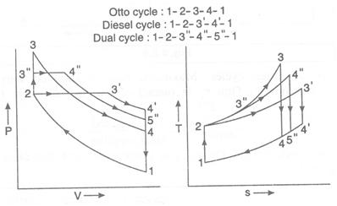 | 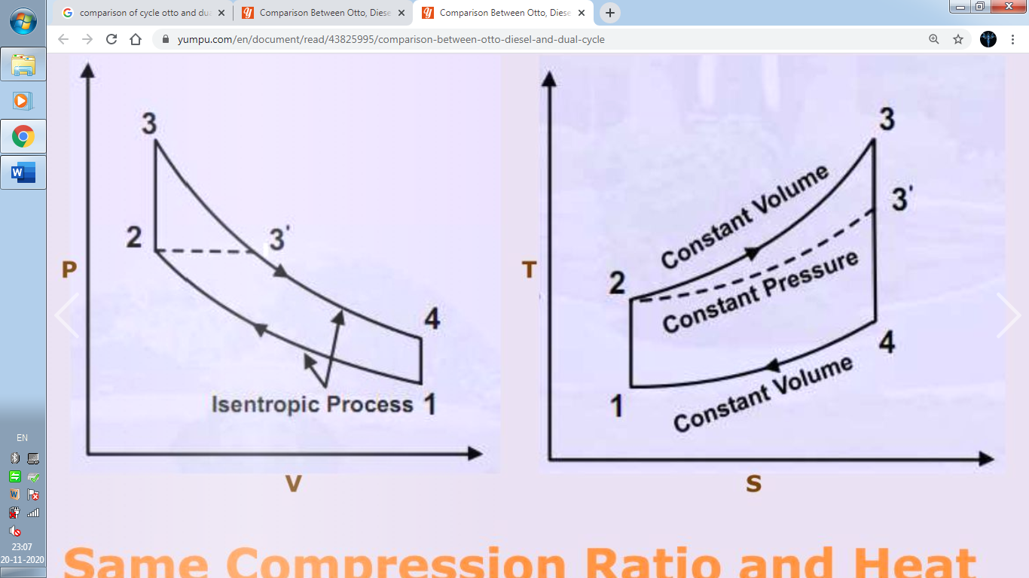 | 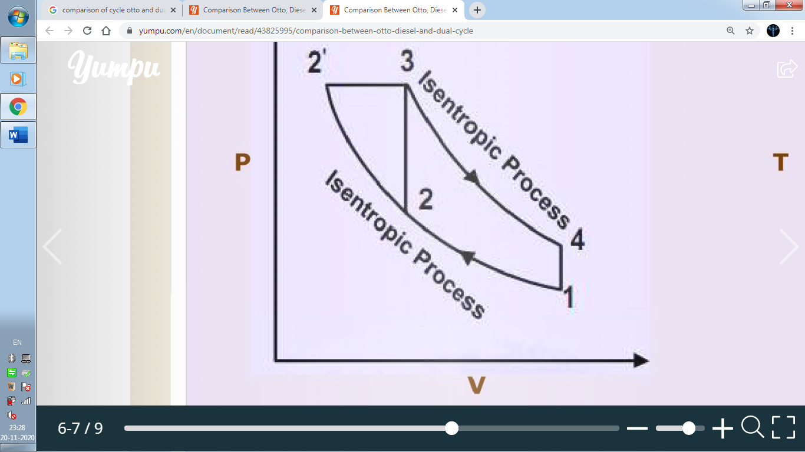
 |  | 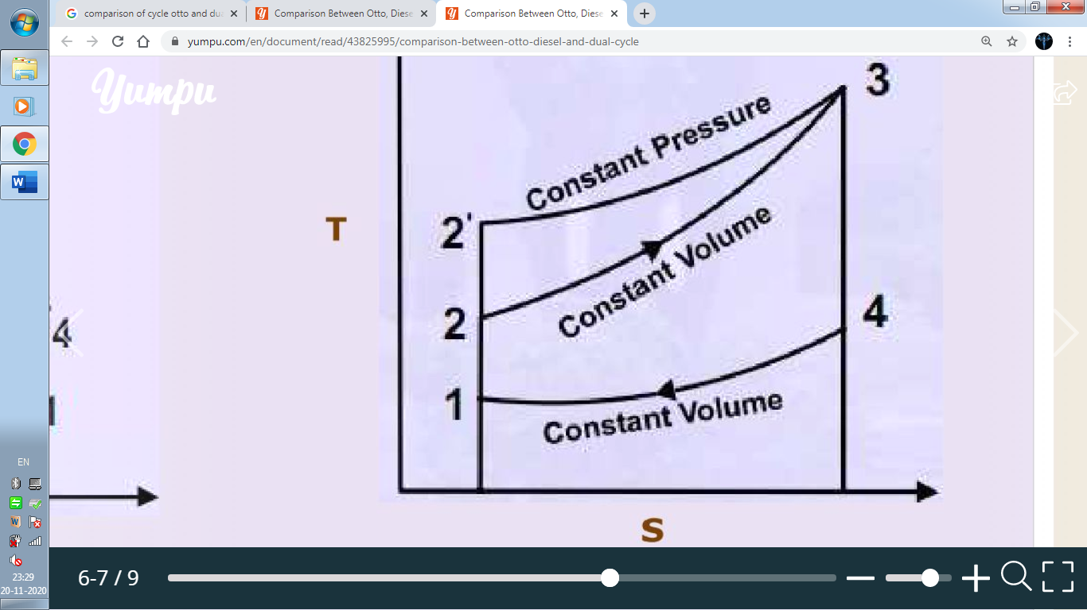 |  | 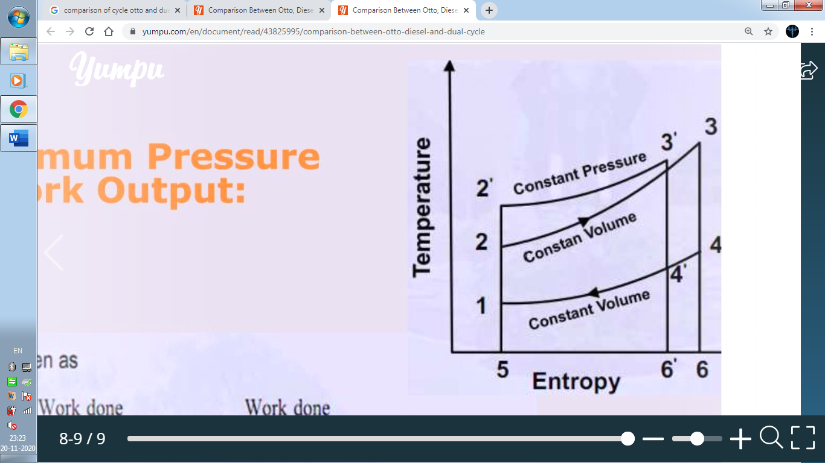
CASE-V: Same Max. Pr. & Same Heat Input  $${\left[Q_{out}\right]}_{otto}>{\left[Q_{out}\right]}_{Diesel}$$  $$η_{Diesel}>η_{Dual}>η_{otto}$$ | 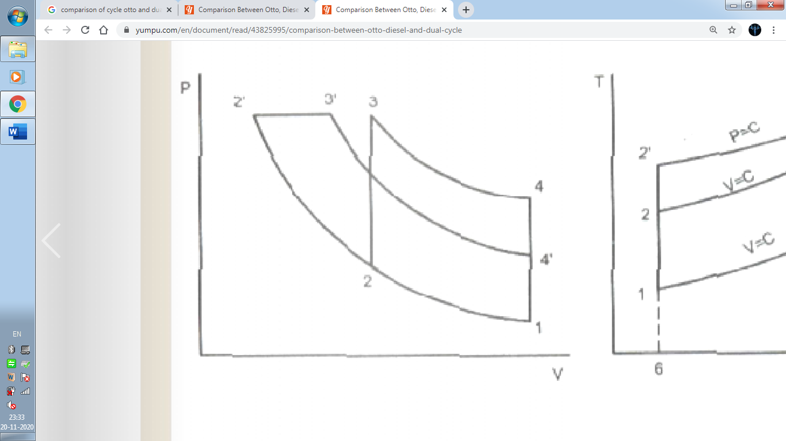 |  | 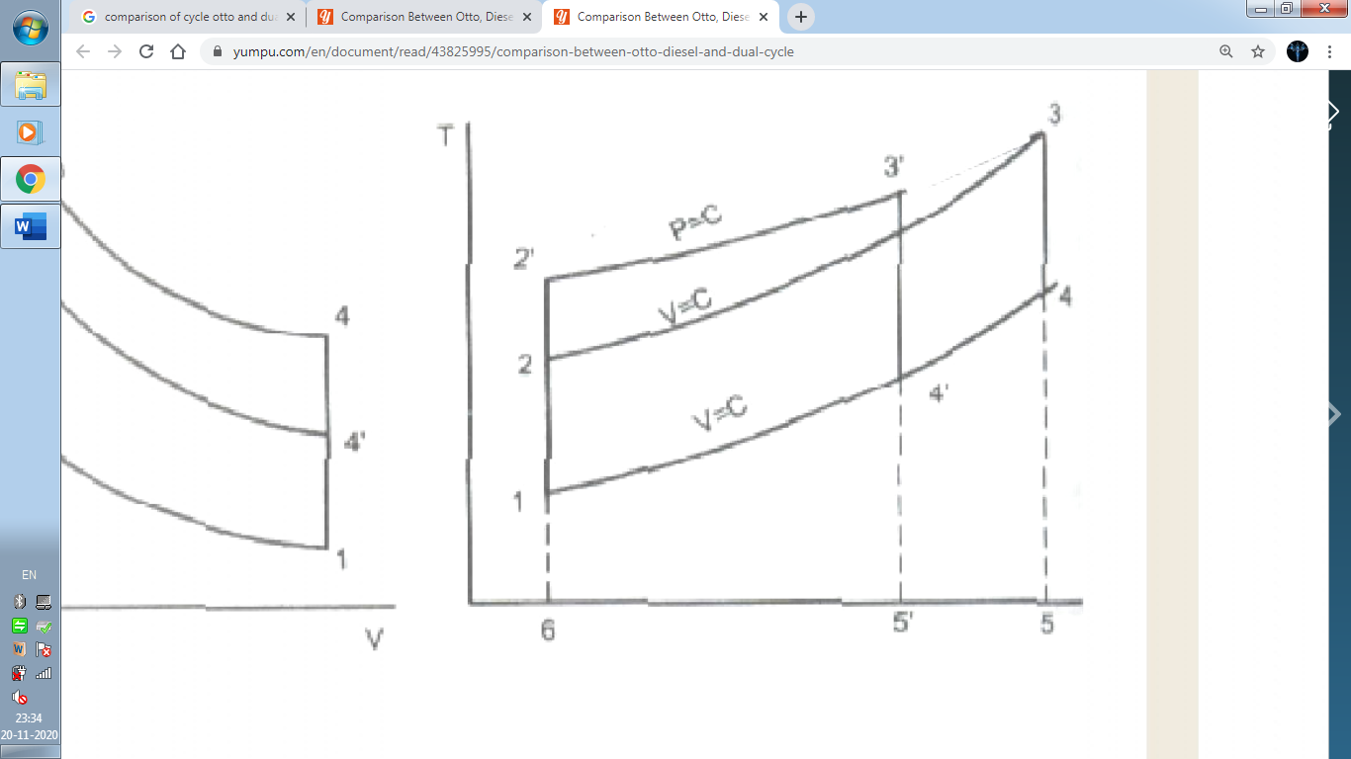

ATKINSON CYCLE: In Otto & Diesel Cycle, when the exhaust valve is opened near the ed of expansion stroke, pressure in the cylinder is still on the order of $3-5 atm$. A potential for doing additional work during the power stroke is therefore lost When exhaust valve is opened & pressure is reduced to atmosphere. If the exhaust valve is not opened until the gas in the cylinder is allowed to expand down to atmospheric pressure. A greater amount of work would be obtained in the expansion stroke with increasing engine efficiency. Such an air standard cycle is called Atkinson Cycle.
For Otto Atkinson Cycle, |  | 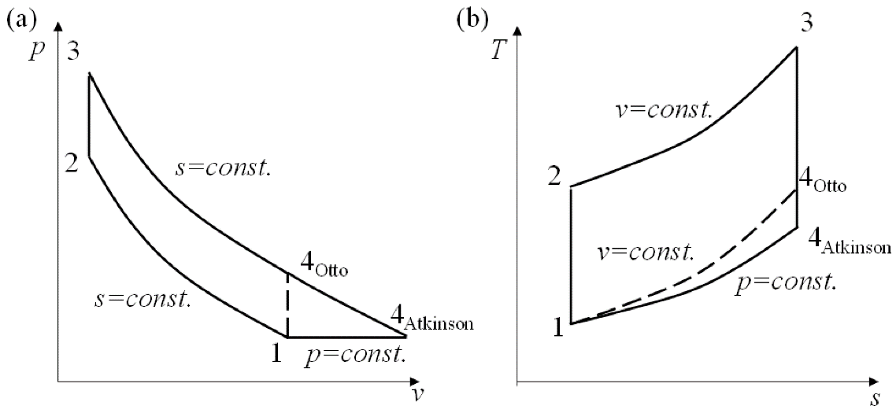  
$$T_{4}=T_{1}$$ | $$V_{1}=V_{2}$$
$$q_{in}=C_{V}\left(T_{3}-T_{2}\right)$$ | $$q_{out}=C_{P}\left(T_{4}-T_{1}\right)$$
$$r=\frac{V_{1}}{V_{2}}$$ | $$r_{p}=\frac{P_{3}}{P_{2}}$$
For 1-2:  $$\frac{T_{2}}{T_{1}}={\left(\frac{V_{1}}{V_{2}}\right)}^{γ-1}=r^{γ-1}$$ | For 2-3,  $$\frac{T_{3}}{T_{2}}=\frac{P_{3}}{P_{2}}=r_{p}$$
For 3-4,
$$\frac{T_{3}}{T_{4}}={\left(\frac{P_{3}}{P_{4}}\right)}^{\frac{γ-1}{γ}}={\left(\frac{P_{3}}{P_{1}}\frac{P_{2}}{P_{2}}\right)}^{\frac{γ-1}{γ}}={\left(r_{P}r^{γ}\right)}^{\frac{γ-1}{γ}}$$
$$η=1-\frac{q_{out}}{q_{in}}=1-\frac{1}{γ}\left[\frac{T_{4}-T_{1}}{T_{3}-T_{2}}\right]=1-\frac{γ}{r^{γ}}\left[\frac{{r_{P}}^{\frac{1}{γ}}-1}{r_{P}-1}\right]$$
ENGINE PERFORMANCE PARAMETERS:
$$C_{avg}=\frac{2LN}{60} \& 5≤C_{avg}≤15$$  Piston speed is limited to avoid material failure & time limitation for flow into or out from cylinder.  $$L=2R$$  Where, $L=$ Stroke length, $R=$ Crank Radius. | 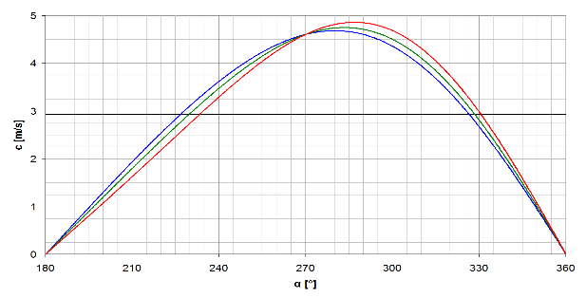
POWER & MECHANICAL EFFICIENCY:
- Power is defined as a rate of doing work is equal to the product of force & linear velocity or product of torque and angular velocity.
- The power developed by an engine at the output shaft is called the brake power. It’s represented by BP.
$$BP=\frac{2πNT}{60}$$ | $$IP=BP+IP$$
- Measurement of power involves the measurement of Force or Torque (measure by Dynamometer) as well as speed (measure by Tachometer).
- Total power developed by combustion of fuel in the combustion chamber is however more than Brake Power (BP) & is called indicated power (IP). Some of the power consumed in overcoming friction between moving parts known as friction power (FP).
Chemical Energy of fuel | Combustion | Heat  $${\dot{Q}}_{in}={\dot{m}}_{f}CV$$ |  | Expansion | Indicated Power |  | Friction Loss | Brake Power
$CV=$ Energy obtained due to complete combustion of the fuel. |  |  |  |  | $${\dot{Q}}_{in}=η_{Combustion}{\dot{m}}_{f} CV$$
$$η_{IP}=\frac{IP}{{\dot{m}}_{f} CV}$$ |  |  | $$η_{BP}=\frac{BP}{{\dot{m}}_{f} CV}$$ |  |  | $$η_{Mech}=\frac{BP}{IP}=\frac{η_{BP}}{η_{IP}}$$
CALORIFIC VALUE (CV)/ HEATING VALUE:
- CV is the amount of heat release due to complete combustion of unit quantity of fuel.
- Bomb calorimeter is used to determine the CV of solids & liquids.
- When the fuel is burned & the product of combustion is cooled to $25°C$ & All the water resulting from the combustion process will be considered when the heating value obtained is called Higher Calorific value.
- The lower or net calorific value is the heat released when $H_{2}O$ is the product of combustion is not condensed and remains in the vapour form.
VOLUMETRIC EFFICIENCY$\left(η_{Vol.}\right)$:
- $η_{Vol.}$ is the indication of the berating ability of the engine.
- It’s defined as the ratio of the mass of air inducted into the engine cylinder during suction stroke to the mass of air corresponding to the swept volume.
- It’s defined as the ratio of actual volume inhaled during suction stroke measured at intake condition to the swept volume of the piston.
NOTE: For supercharged engine the volumetric efficiency is more than unity.
$$Specific Fuel Consumption:SFC=\frac{{\dot{m}}_{f}}{P_{out}}$$
$$BSFC={{\dot{m}}_{f}}/{BP}$$ | $$ISFC={{\dot{m}}_{f}}/{IP}$$
AIR FUEL RATIO ($A:F$): It’s ratio of mass of air to the mass of fuel.  Note:  - Practically in SI engine the fuel air ratio is remains constant over a wide range of operation. The air flow does not vary with load. Therefore, the term fuel air ratio is generally used instead of air fuel ratio.  - SI engine is Quality governing and CI engine is Quantity governing engine.  RELATIVE FUEL AIR RATIO:  $$∅=\frac{{\left[F:A\right]}_{Actual}}{{\left[F:A\right]}_{Stichometric}}=\frac{{\left[A:F\right]}_{Stichometric}}{{\left[A:F\right]}_{Actual}}$$ |  | 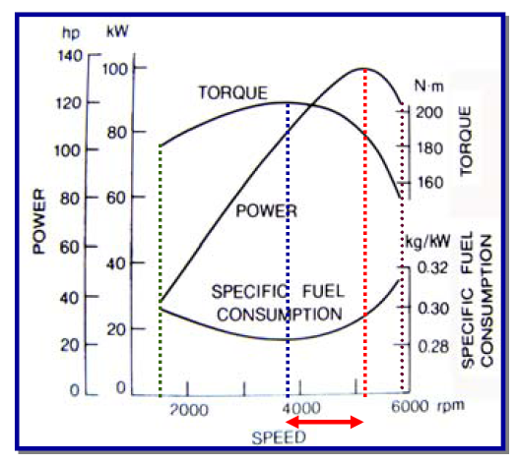
MEAN EFFECTIVE PRESSURE ($P_{m}$):
- The Pressure in the cylinder of engine is continuously changing during the cycle.
- Mean Effective pressure $P_{m}$ is defined as the hypothetical pressure which is thought to be acting on the piston throughout the cycle.
$$\frac{W_{net}}{Cycle}=P_{m}\left(V_{2}-V_{1}\right)=P_{m}V_{Stroke}=P_{m}AL$$  $$Power=\frac{W_{net}}{Cycle}\frac{Cycle}{S}=\frac{P_{m}ALn}{60}$$  For 2 Stroke Engine, $n=N$  For 4 Stroke Engine, $n=N/2$ | 